**PIZZA SALES REPORT**

1. KPI

**Total Revenue:**

SELECT SUM(total_price) AS Total FROM pizza;

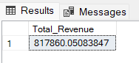

**Average Order Value:**

SELECT SUM (total_price)/COUNT (DISTINCT order_id) AS Avg_order_value FROM pizza;

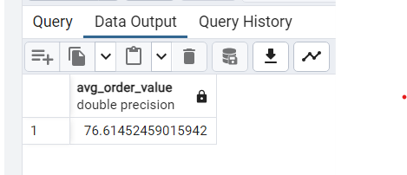

**Total Pizza Sold:**

SELECT SUM (quantity) AS Total_pizza_sold FROM pizza;

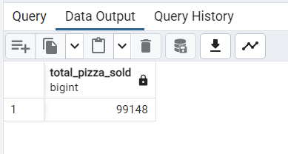

**Total Order:**

SELECT COUNT(DISTINCT order_id) AS Total_order FROM pizza;

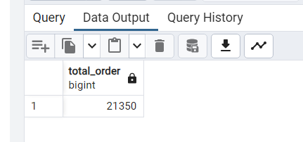

**Average Pizza Per Order:**

SELECT CAST(SUM(quantity) AS DECIMAL(10,2))/CAST(COUNT(DISTINCT order_id) AS DECIMAL(10,2)) AS Avg_pizza_per_order FROM pizza;

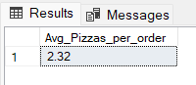

**2. Daily Trend for Total Orders**

SELECT TO_CHAR(order_date, 'Day') AS Order_day, COUNT(DISTINCT order_id) AS Total_order FROM pizza GROUP BY Order_day;

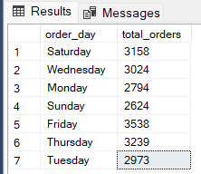

**3. Monthly Trend for Orders**

SELECT TO_CHAR(order_date,'Month') AS Order_month, COUNT(DISTINCT order_id) AS Total_order FROM pizza

GROUP BY Order_month;

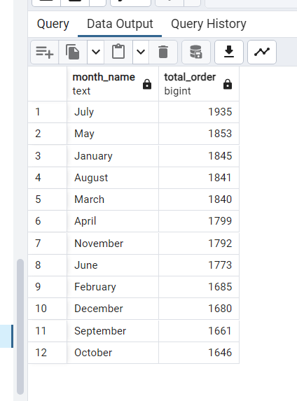

**4. % of Sales by Pizza Category**

SELECT pizza_category, CAST(SUM(total_price) AS DECIMAL(10,2)) as Total_revenue,CAST(SUM(total_price) * 100 / (SELECT SUM(total_price) from pizza) AS DECIMAL(10,2)) AS PCT FROM pizza GROUP BY pizza_category;

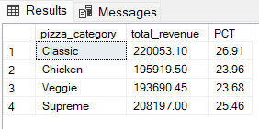

**5. % of Sales by Pizza Size**

SELECT pizza_size, CAST(SUM(total_price) AS DECIMAL(10,2)) as Total_revenue,

CAST(SUM(total_price) * 100 / (SELECT SUM(total_price) from pizza) AS DECIMAL(10,2)) AS PCT FROM pizza GROUP BY pizza_size ORDER BY pizza_size;

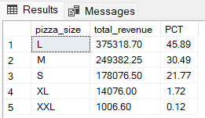

**6. Total Pizzas Sold by Pizza Category**

SELECT pizza_category, SUM(quantity) as Total_quantity_sold FROM pizza GROUP BY pizza_category ORDER BY Total_quantity_sold DESC;

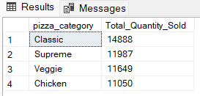

**8. Top 5 Pizzas by Revenue**

SELECT pizza_name, SUM(total_price) AS Total_revenue FROM pizza GROUP BY pizza_name ORDER BY Total_revenue DESC LIMIT 5;

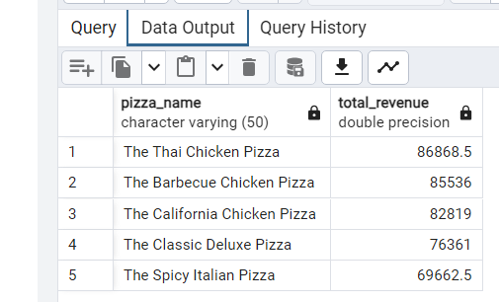

**9. Bottom 5 Pizzas by Revenue**

SELECT pizza_name, SUM(total_price) AS Total_revenue FROM pizza GROUP BY pizza_name ORDER BY Total_revenue ASC LIMIT 5;

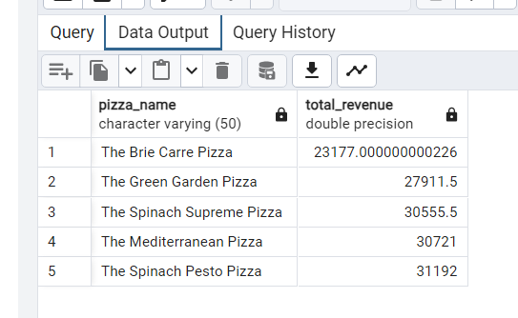

**10. Top 5 Pizzas by Quantity**

SELECT pizza_name, SUM(quantity) AS Total_pizza_sold FROM pizza GROUP BY pizza_name ORDER BY Total_pizza_sold DESC LIMIT 5;

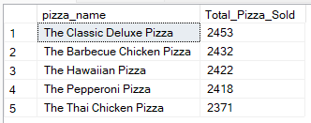

**11. Bottom 5 Pizzas by Quantity**

SELECT pizza_name, SUM(quantity) AS Total_pizza_sold FROM pizza GROUP BY pizza_name ORDER BY Total_pizza_sold ASC LIMIT 5;

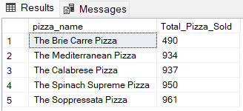

**12. Top 5 Pizzas by Total Orders**

SELECT pizza_name,SUM(DISTINCT order_id) AS Total_order FROM pizza GROUP BY pizza_name ORDER BY Total_order DESC LIMIT 5;

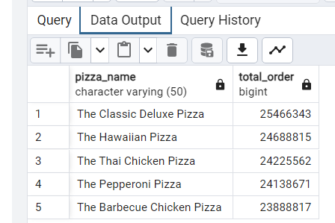

**13. Borrom 5 Pizzas by Total Orders**

SELECT pizza_name,SUM(DISTINCT order_id) AS Total_order FROM pizza GROUP BY pizza_name ORDER BY Total_order ASC LIMIT 5;

